**ISQA 8210- Assignment 3**

Building Construction Materials Supply

**Description:**

The **Building Construction Materials Supply Application** is for online shoppers. Anyone (Visitor) can view our products (construction Materials) and categories, but the user needs to log in if he/she wants to order a product or Request for Quotation. In case the user does not have an account, he/she can sign up and log in to our website. Apart from visitors and customers, there will be a superuser(admin) and employees. The superuser(admin) will have all permission by default. For example, the admin can manage employee permissions and user permissions.

**Use Case Diagram:**

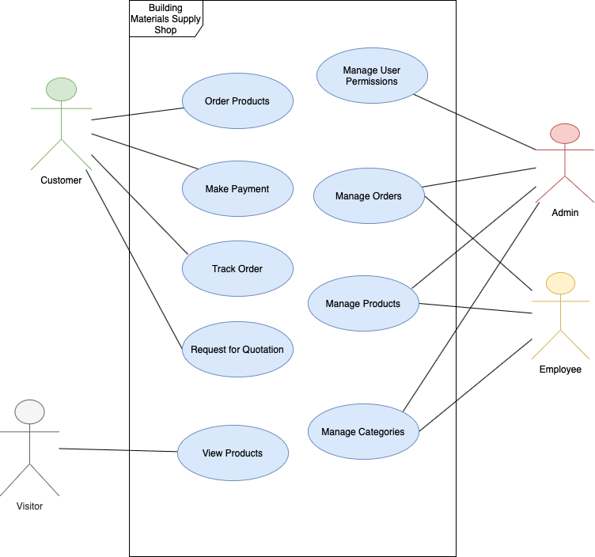

**Entity Relationship Diagram:**

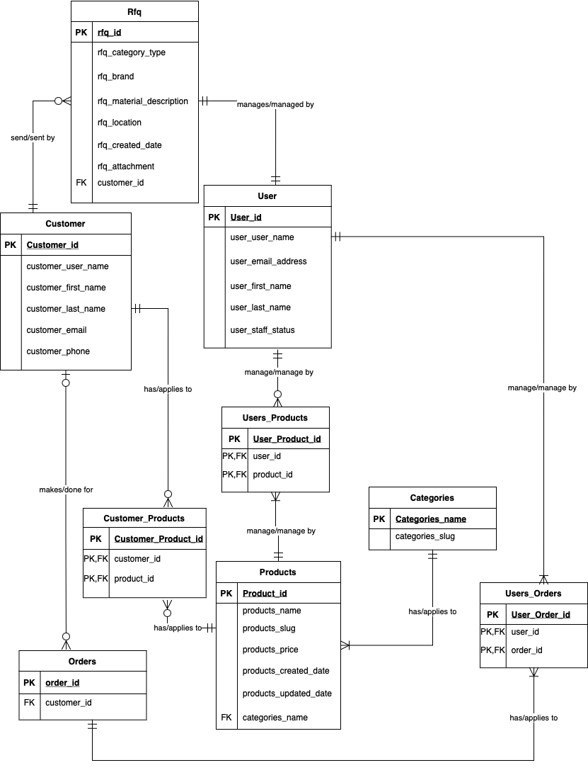

**Mockups:**

Admin Panel login page:

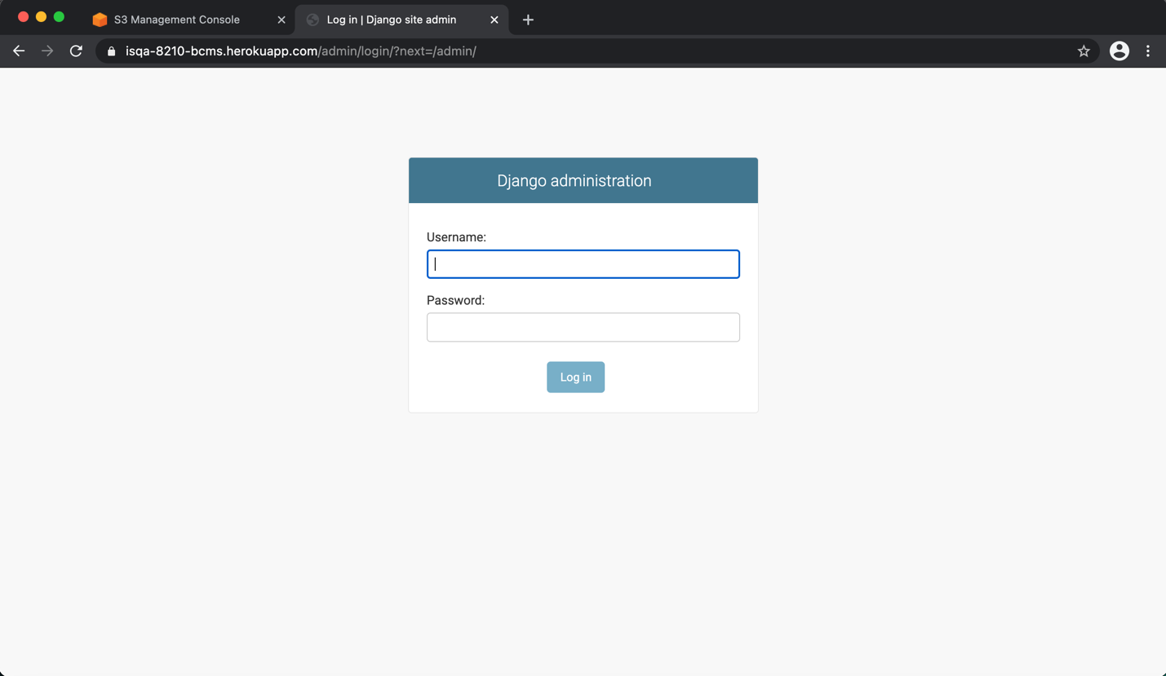

Admin Panel Home Page:

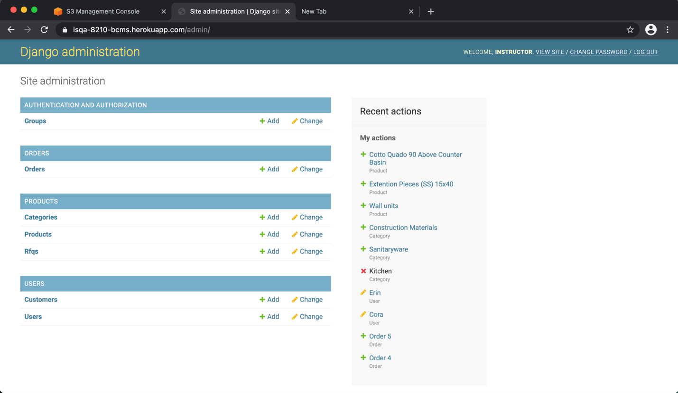

List Group Page:

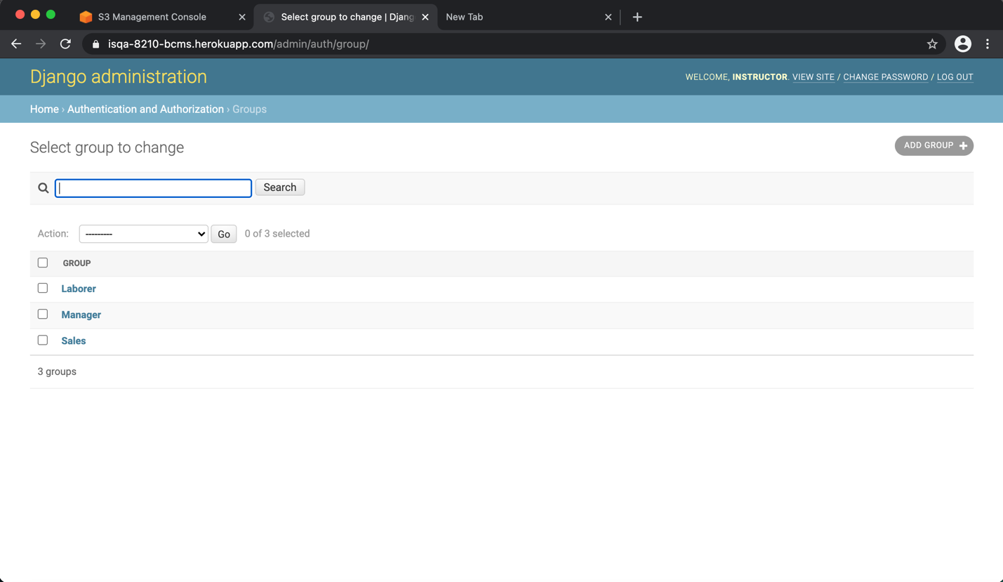

Add Group Page:

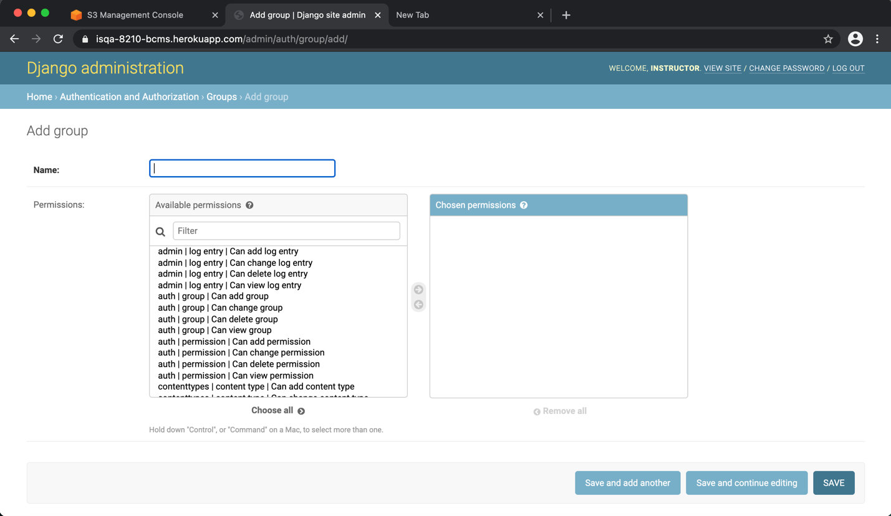

Edit Group Page:

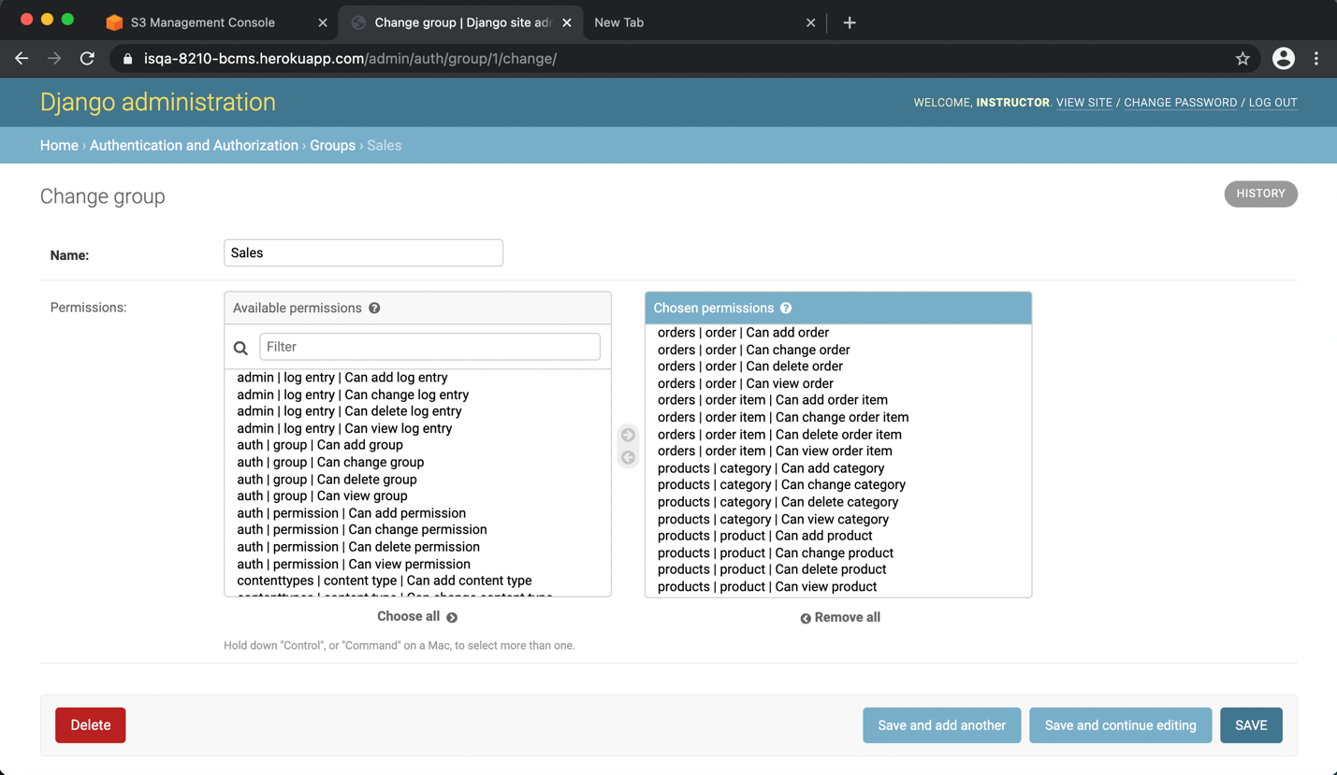

Delete Group Page:

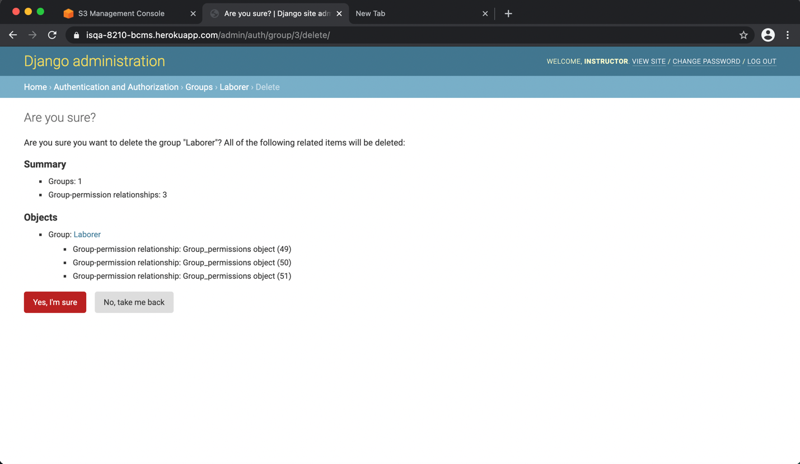

List Orders Page:

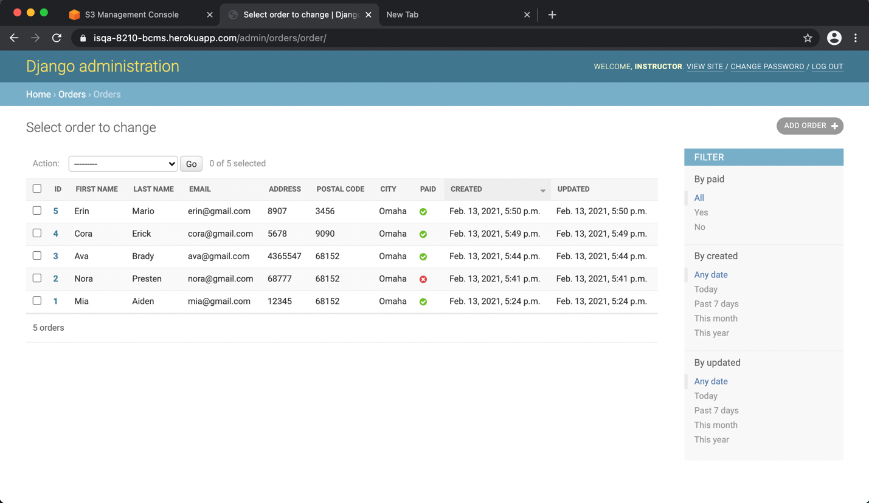

Add Orders Page:

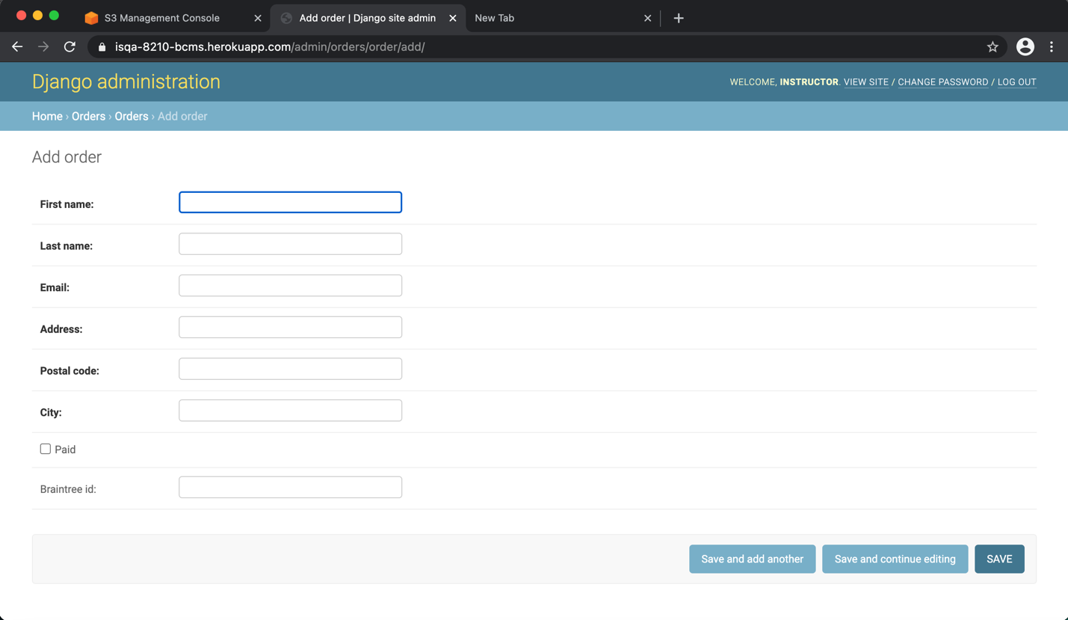

Edit Orders Page:

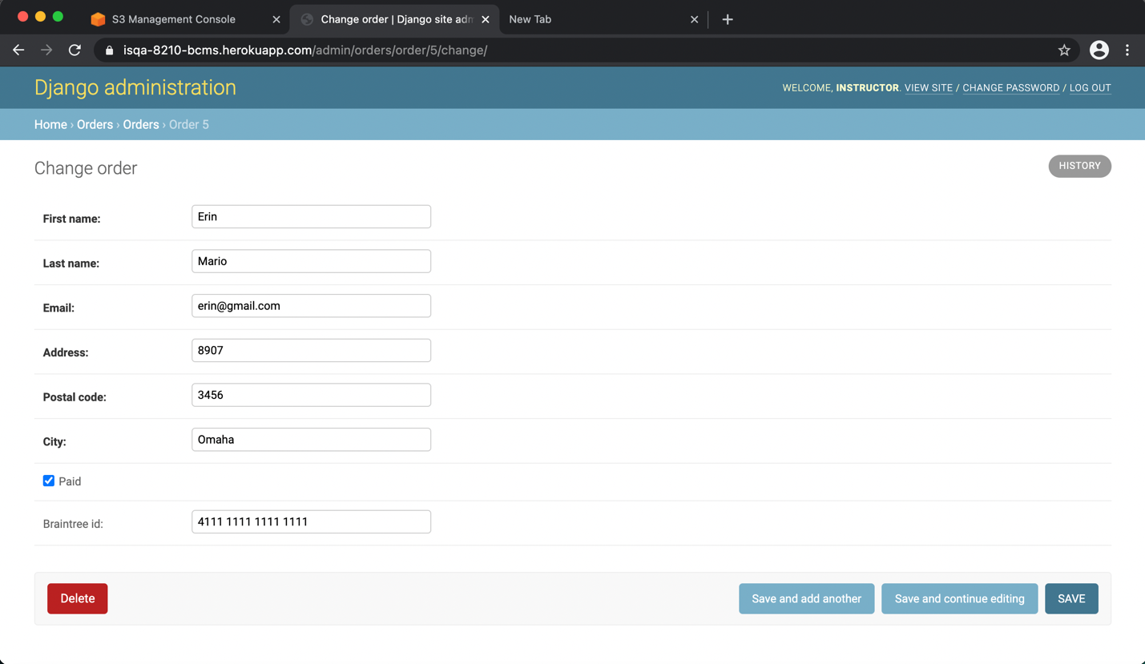

Delete Orders Page:

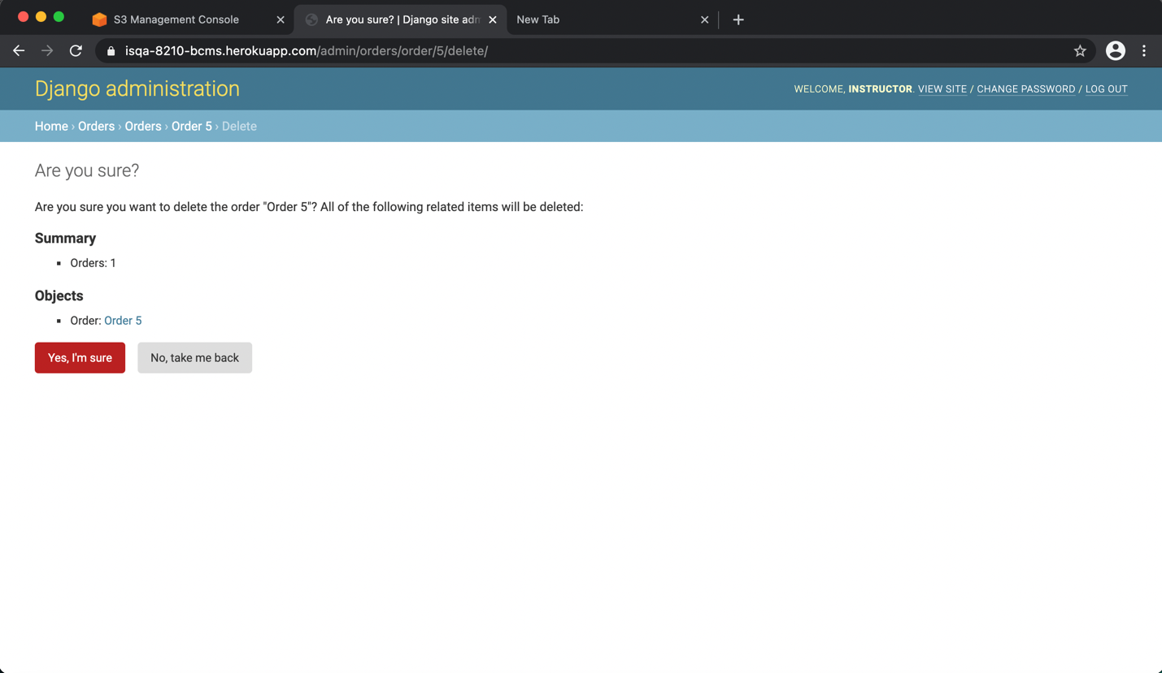

List Categories Page:

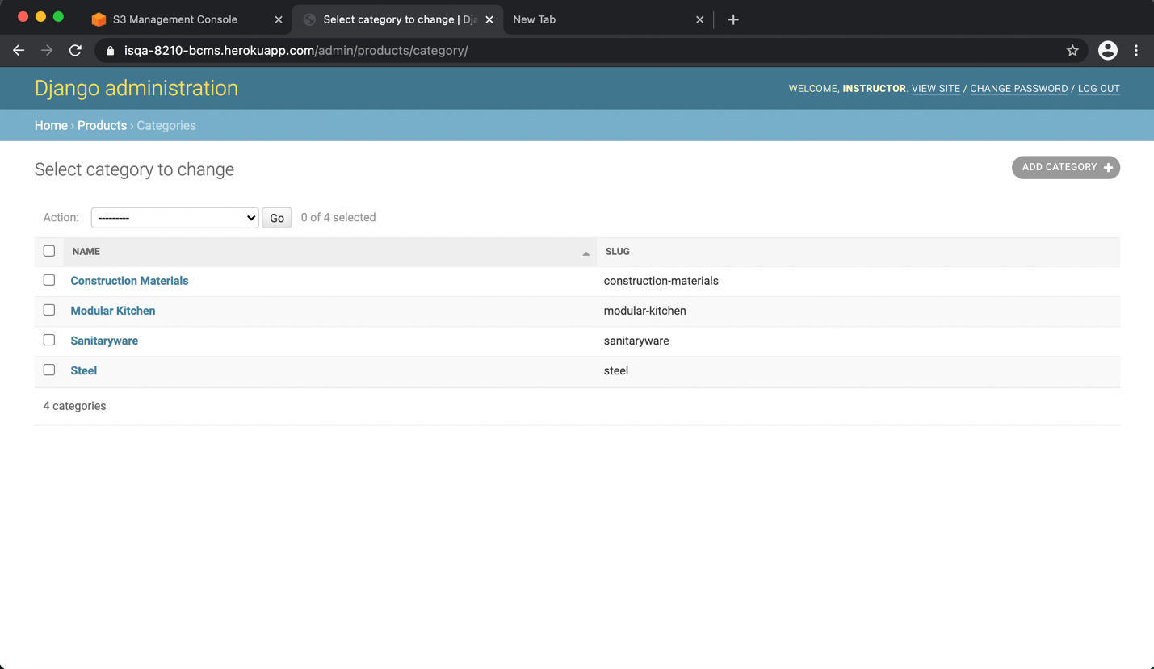

Add Categories Page:

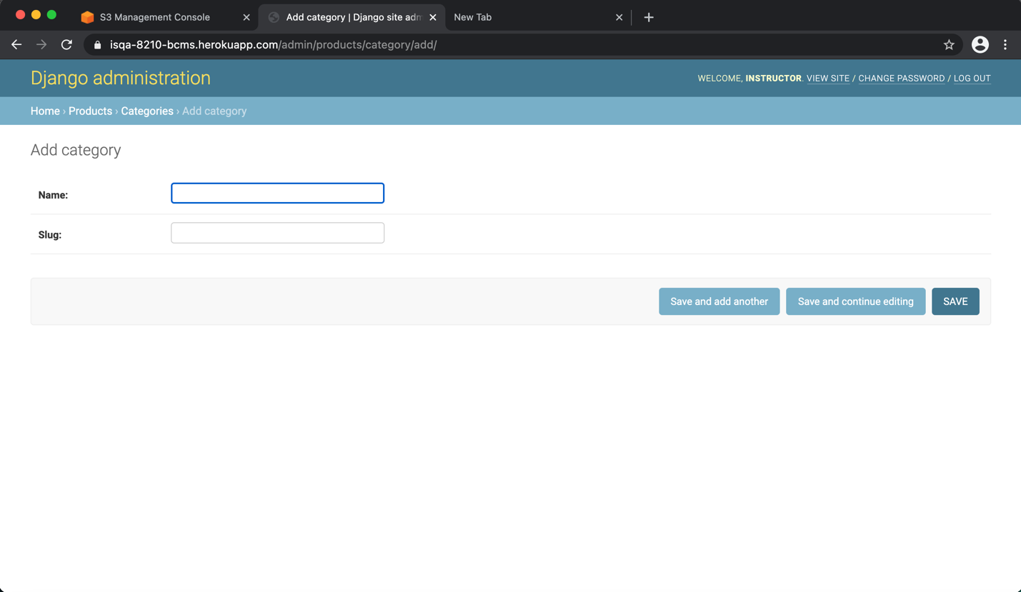

Edit Categories Page:

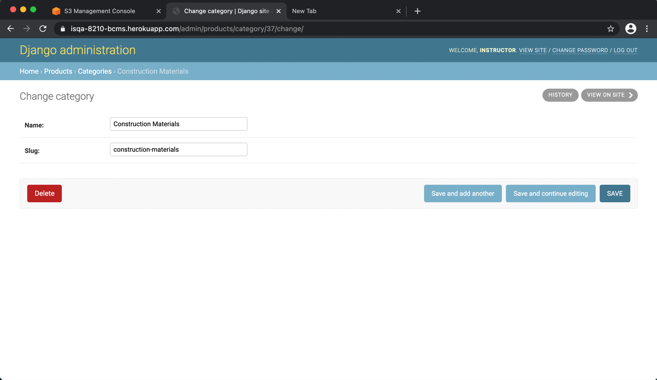

Delete Categories Page:

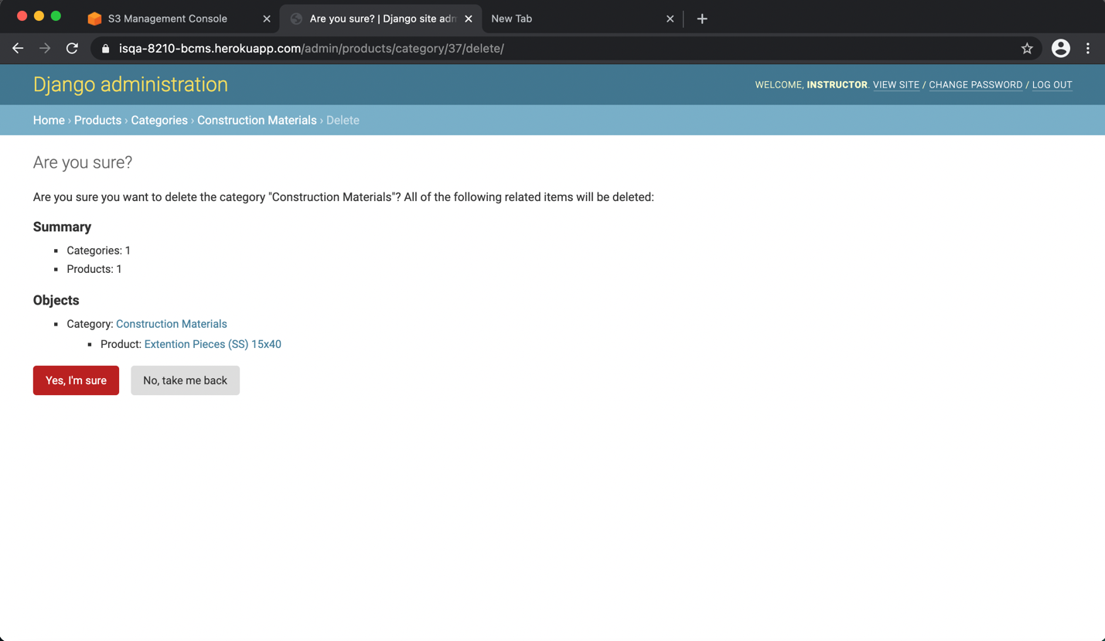

List Products Page:

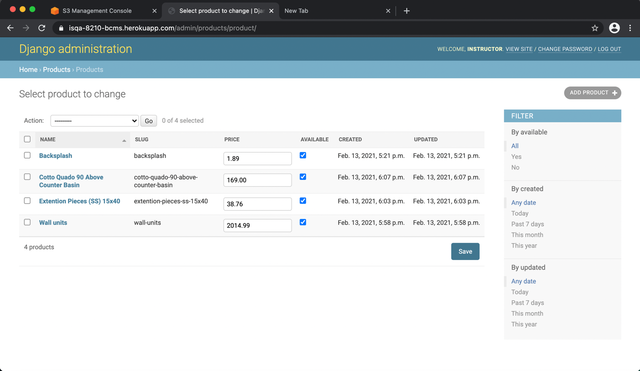

Add Product Page:

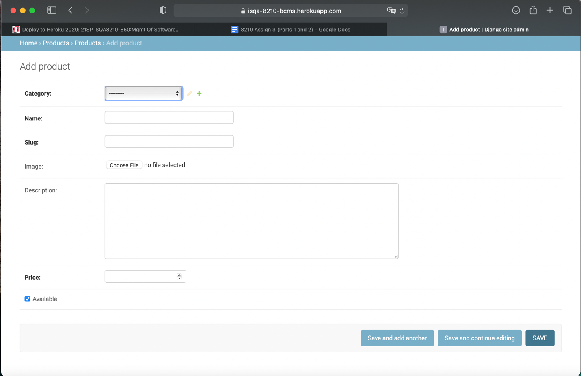

Product image:

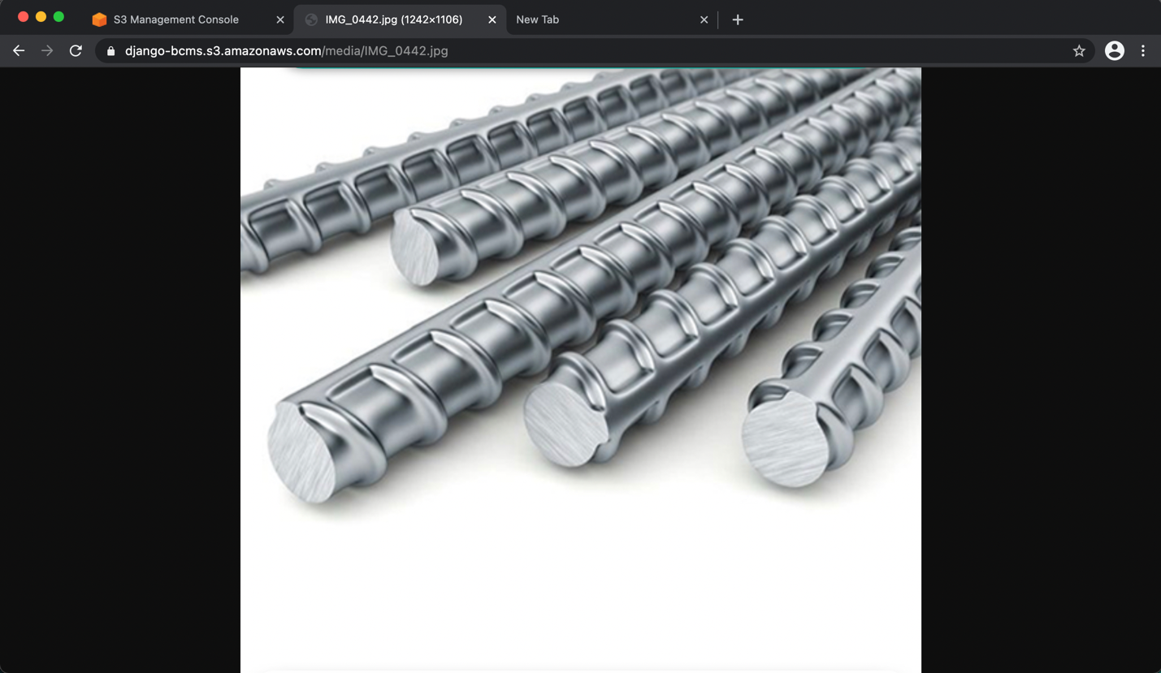

Edit Product Page:

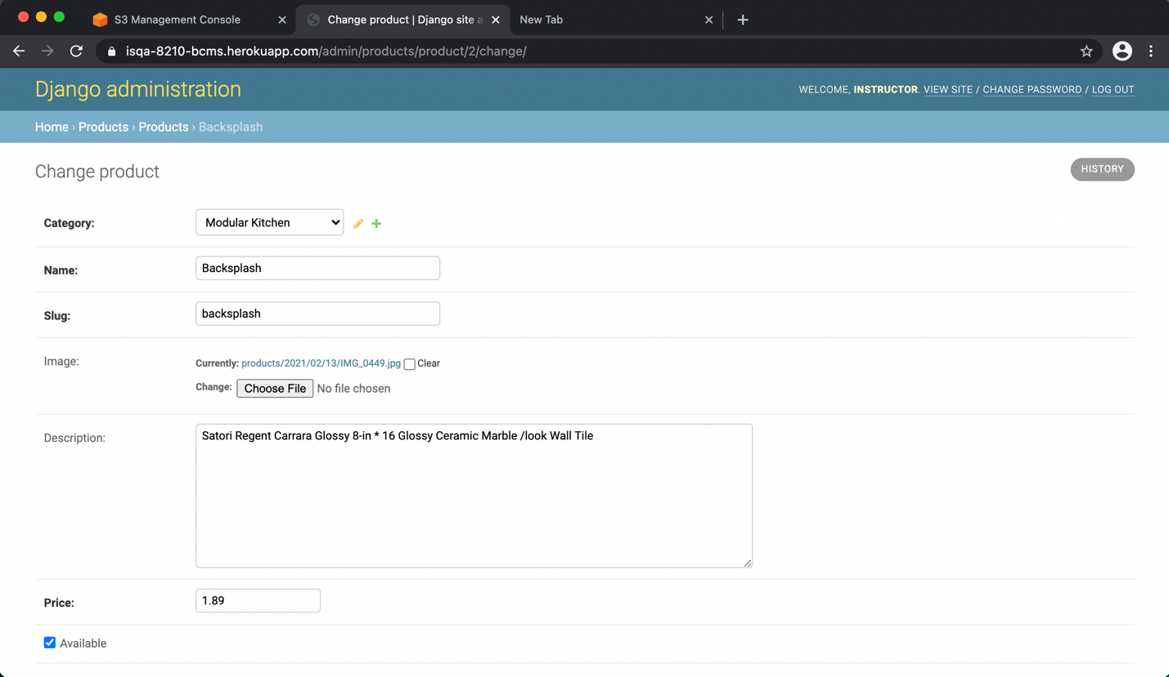

Delete Product Page:

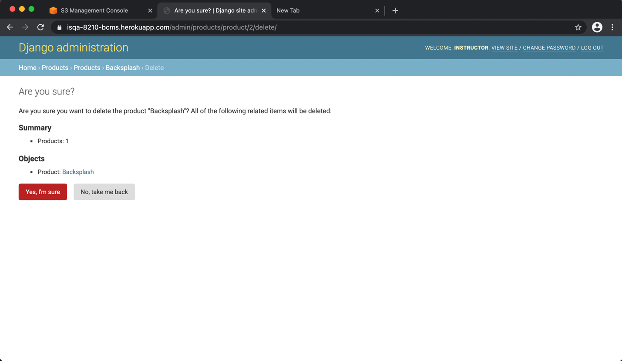

List Customer Page:

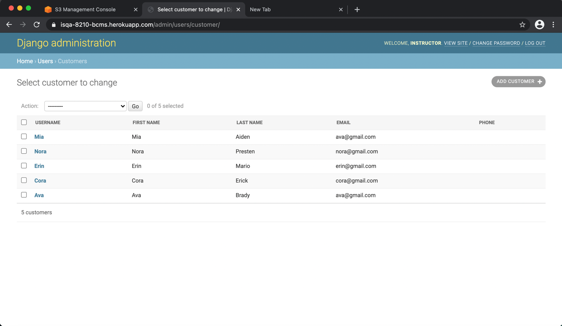

Edit Customer Page:

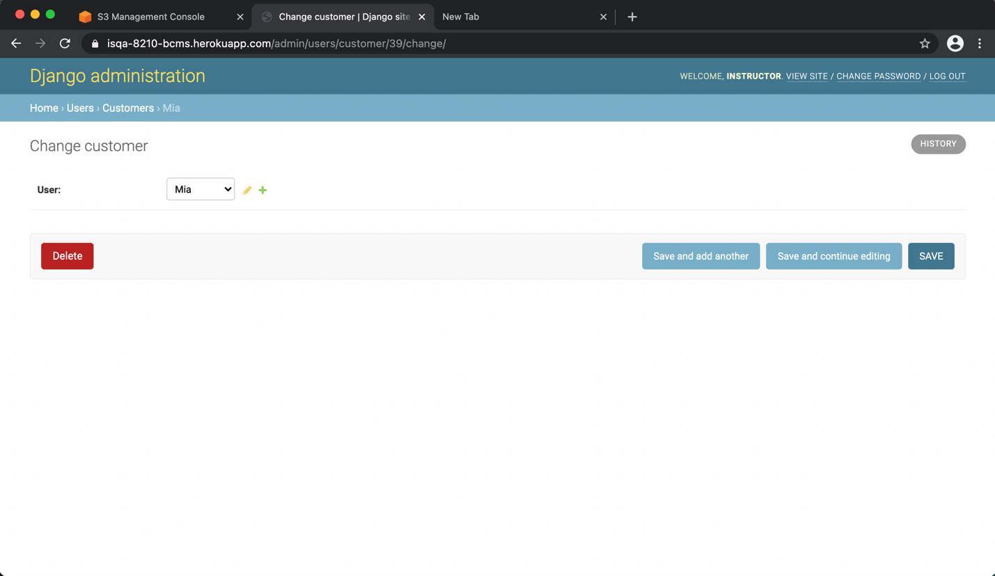

Delete Customer:

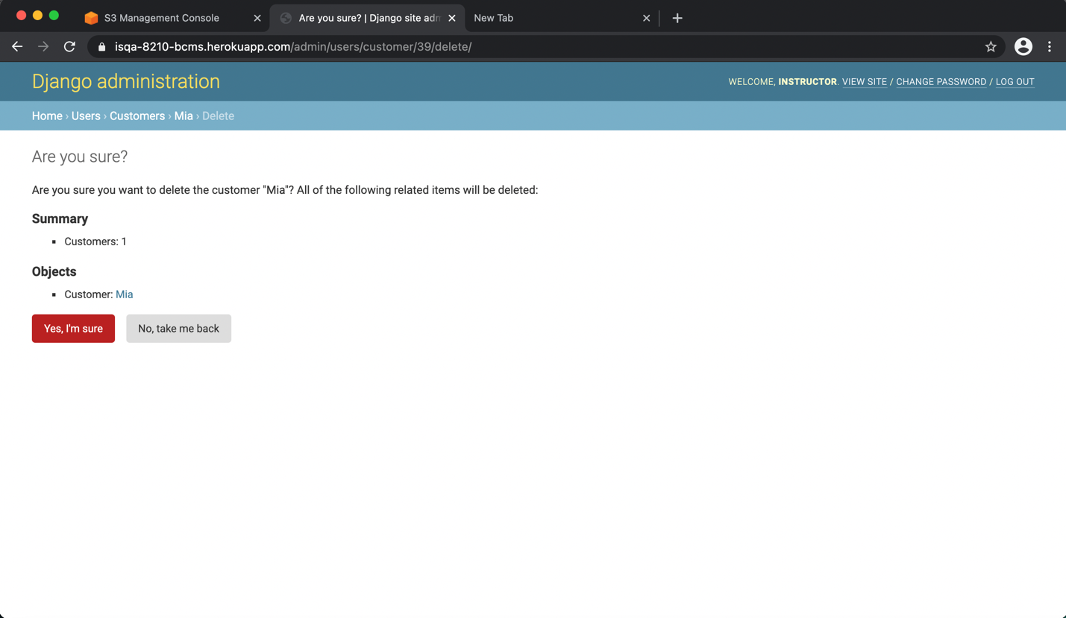

Add User Page:

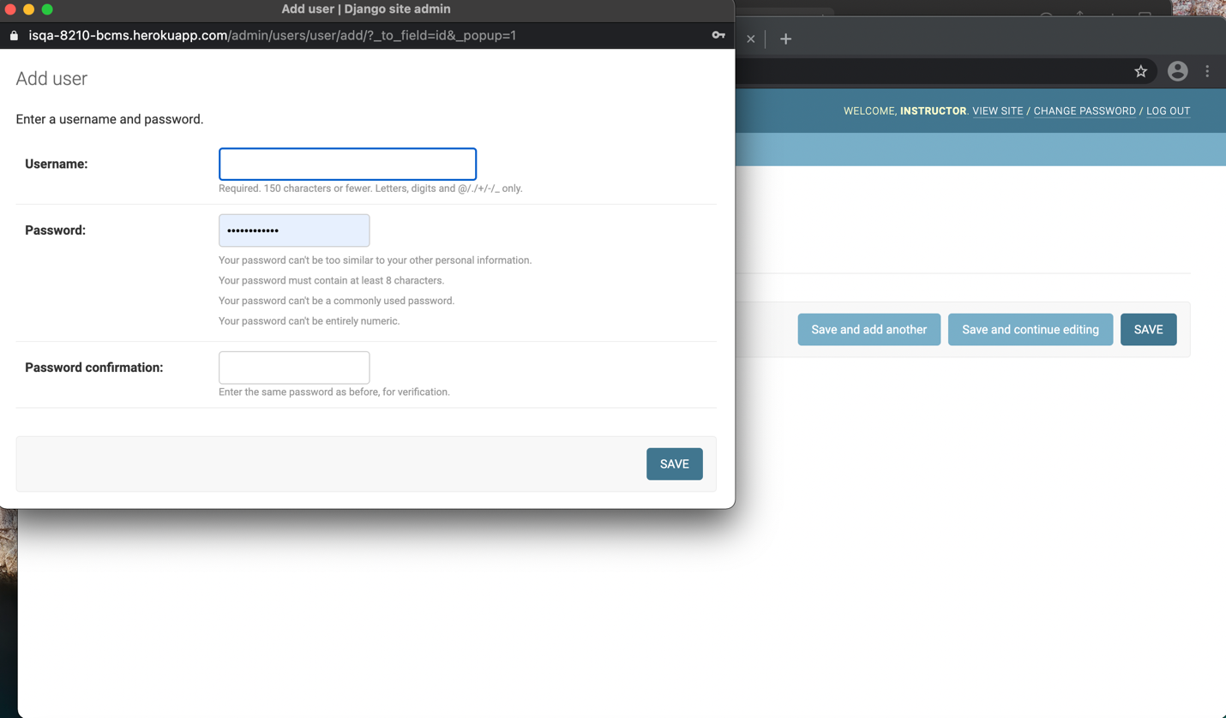

File Stored in AWS S3 bucket:

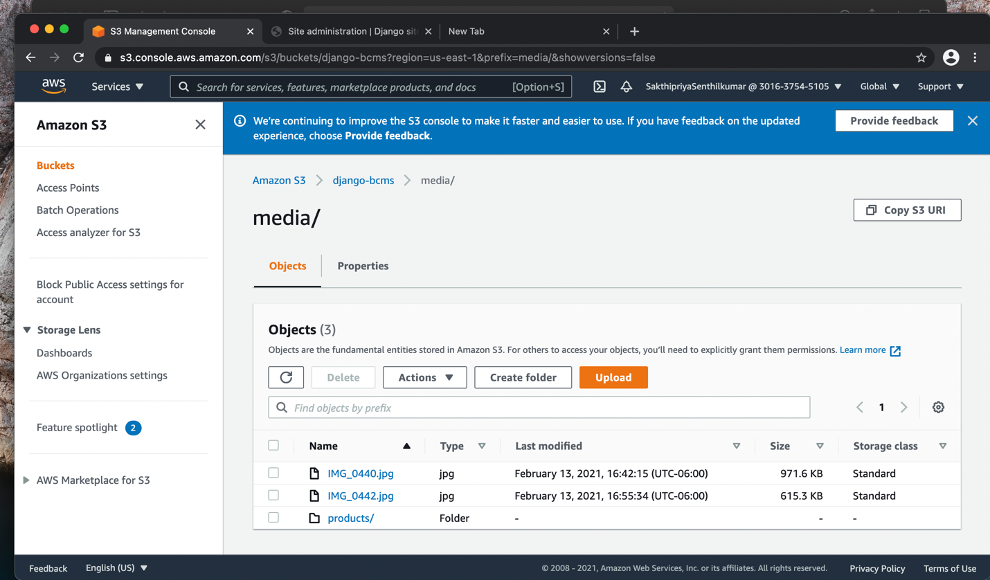

List RFQ File Page:

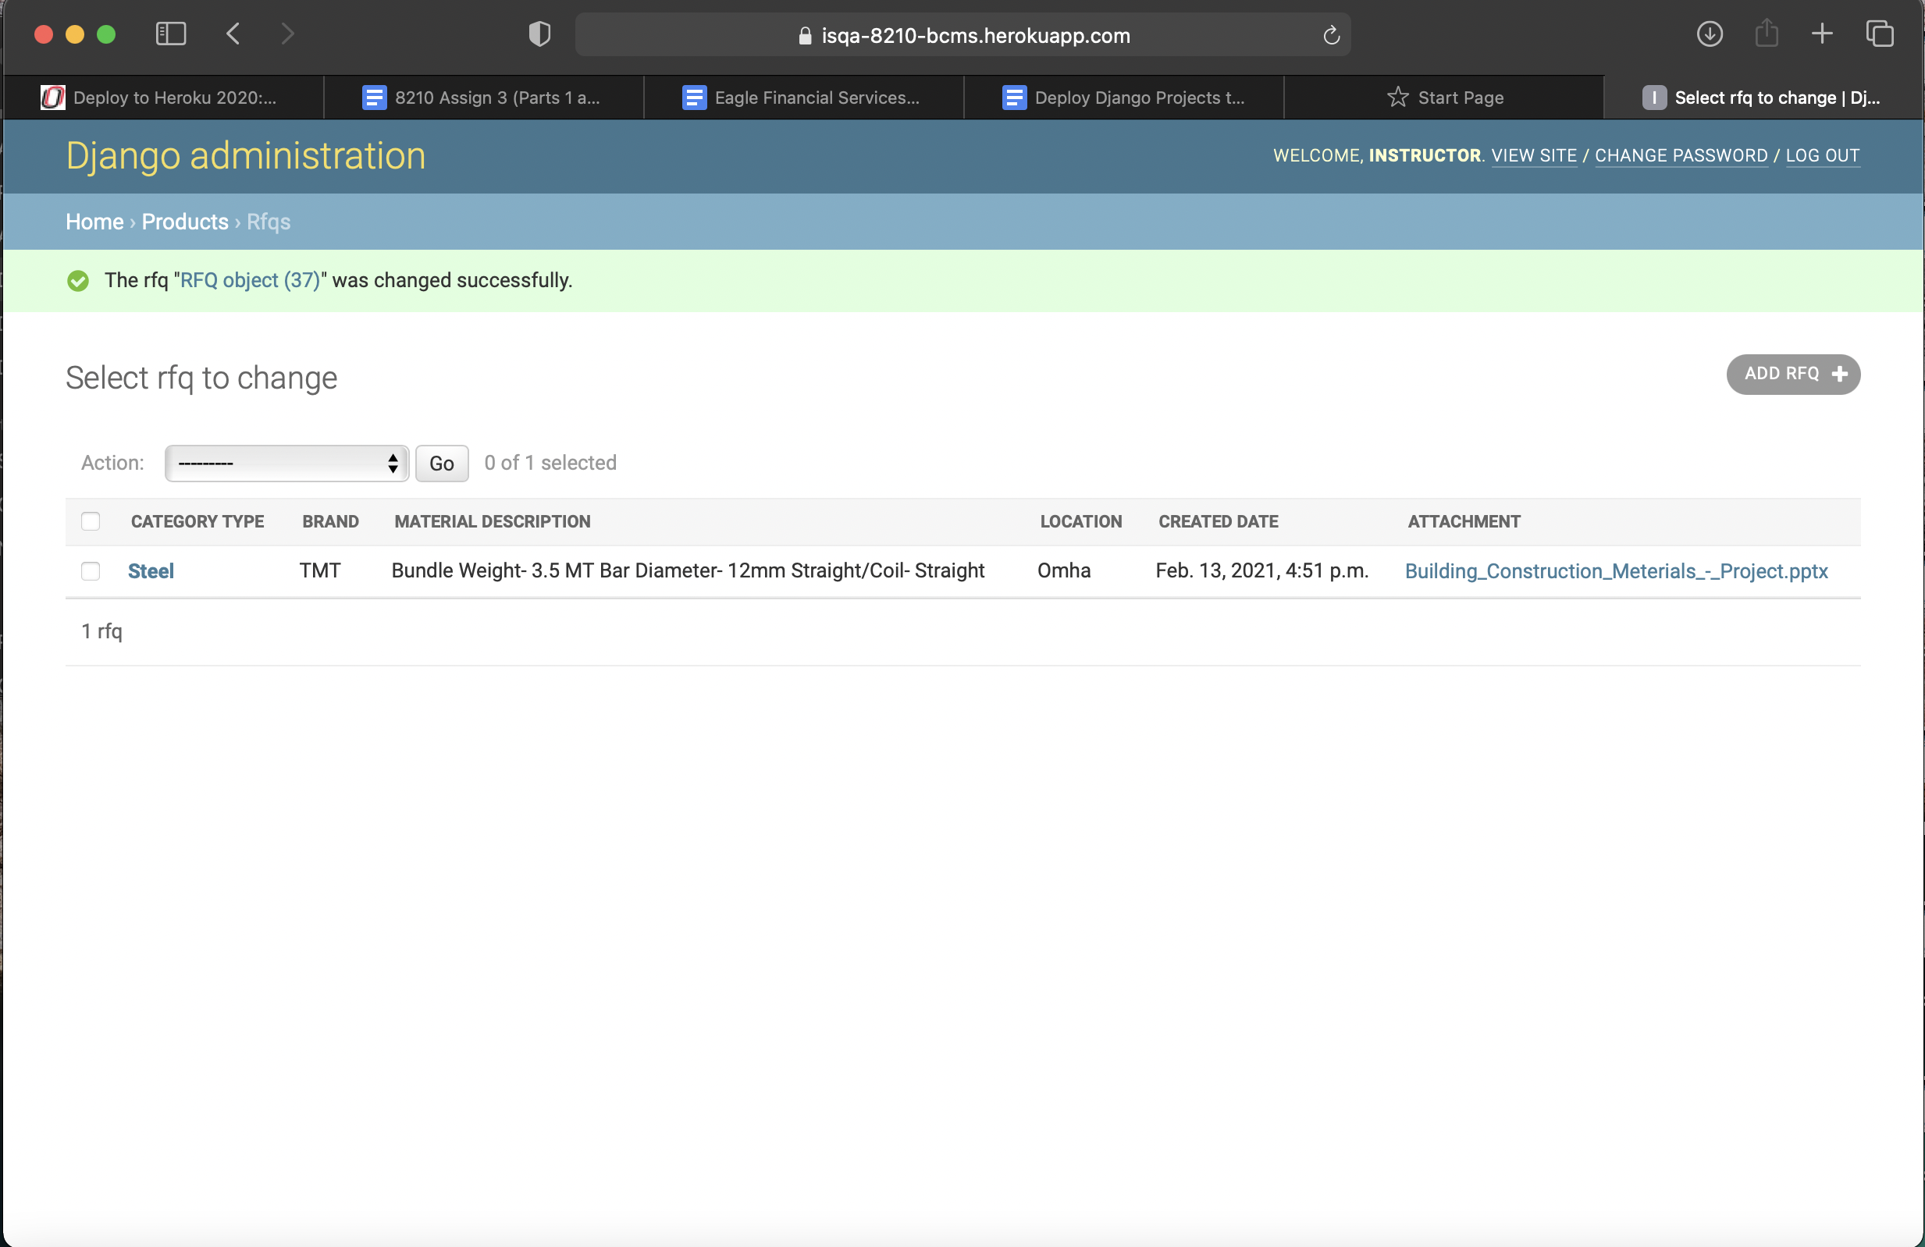

Customer can send Request for Quotation and can upload any type of file. Admin can add, view edit and delete the request form.

Add RFQ Page:



Choose File RFQ Page:

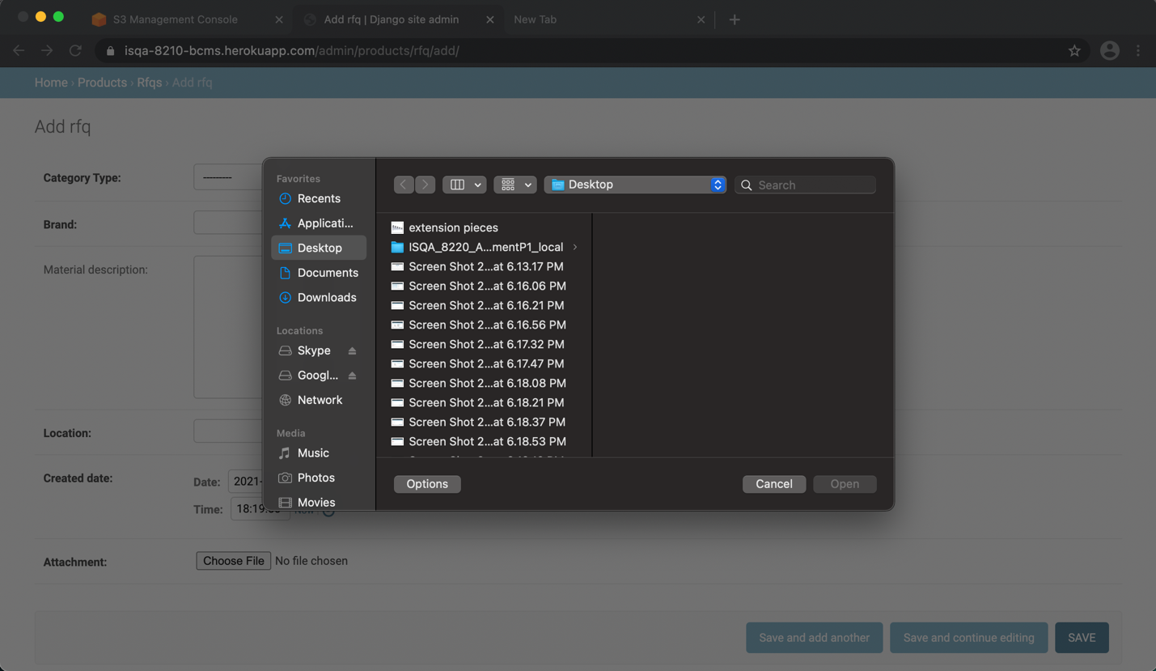

Edit RFQ Page:

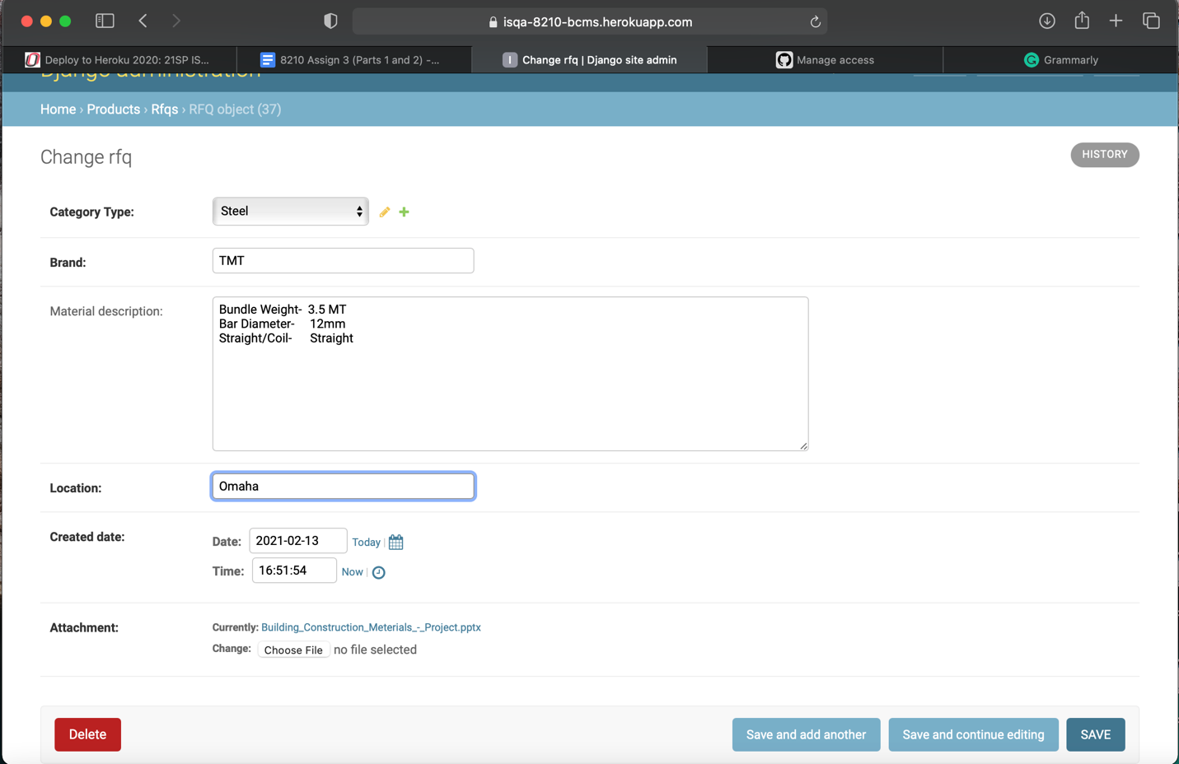

Delete RFQ Page:

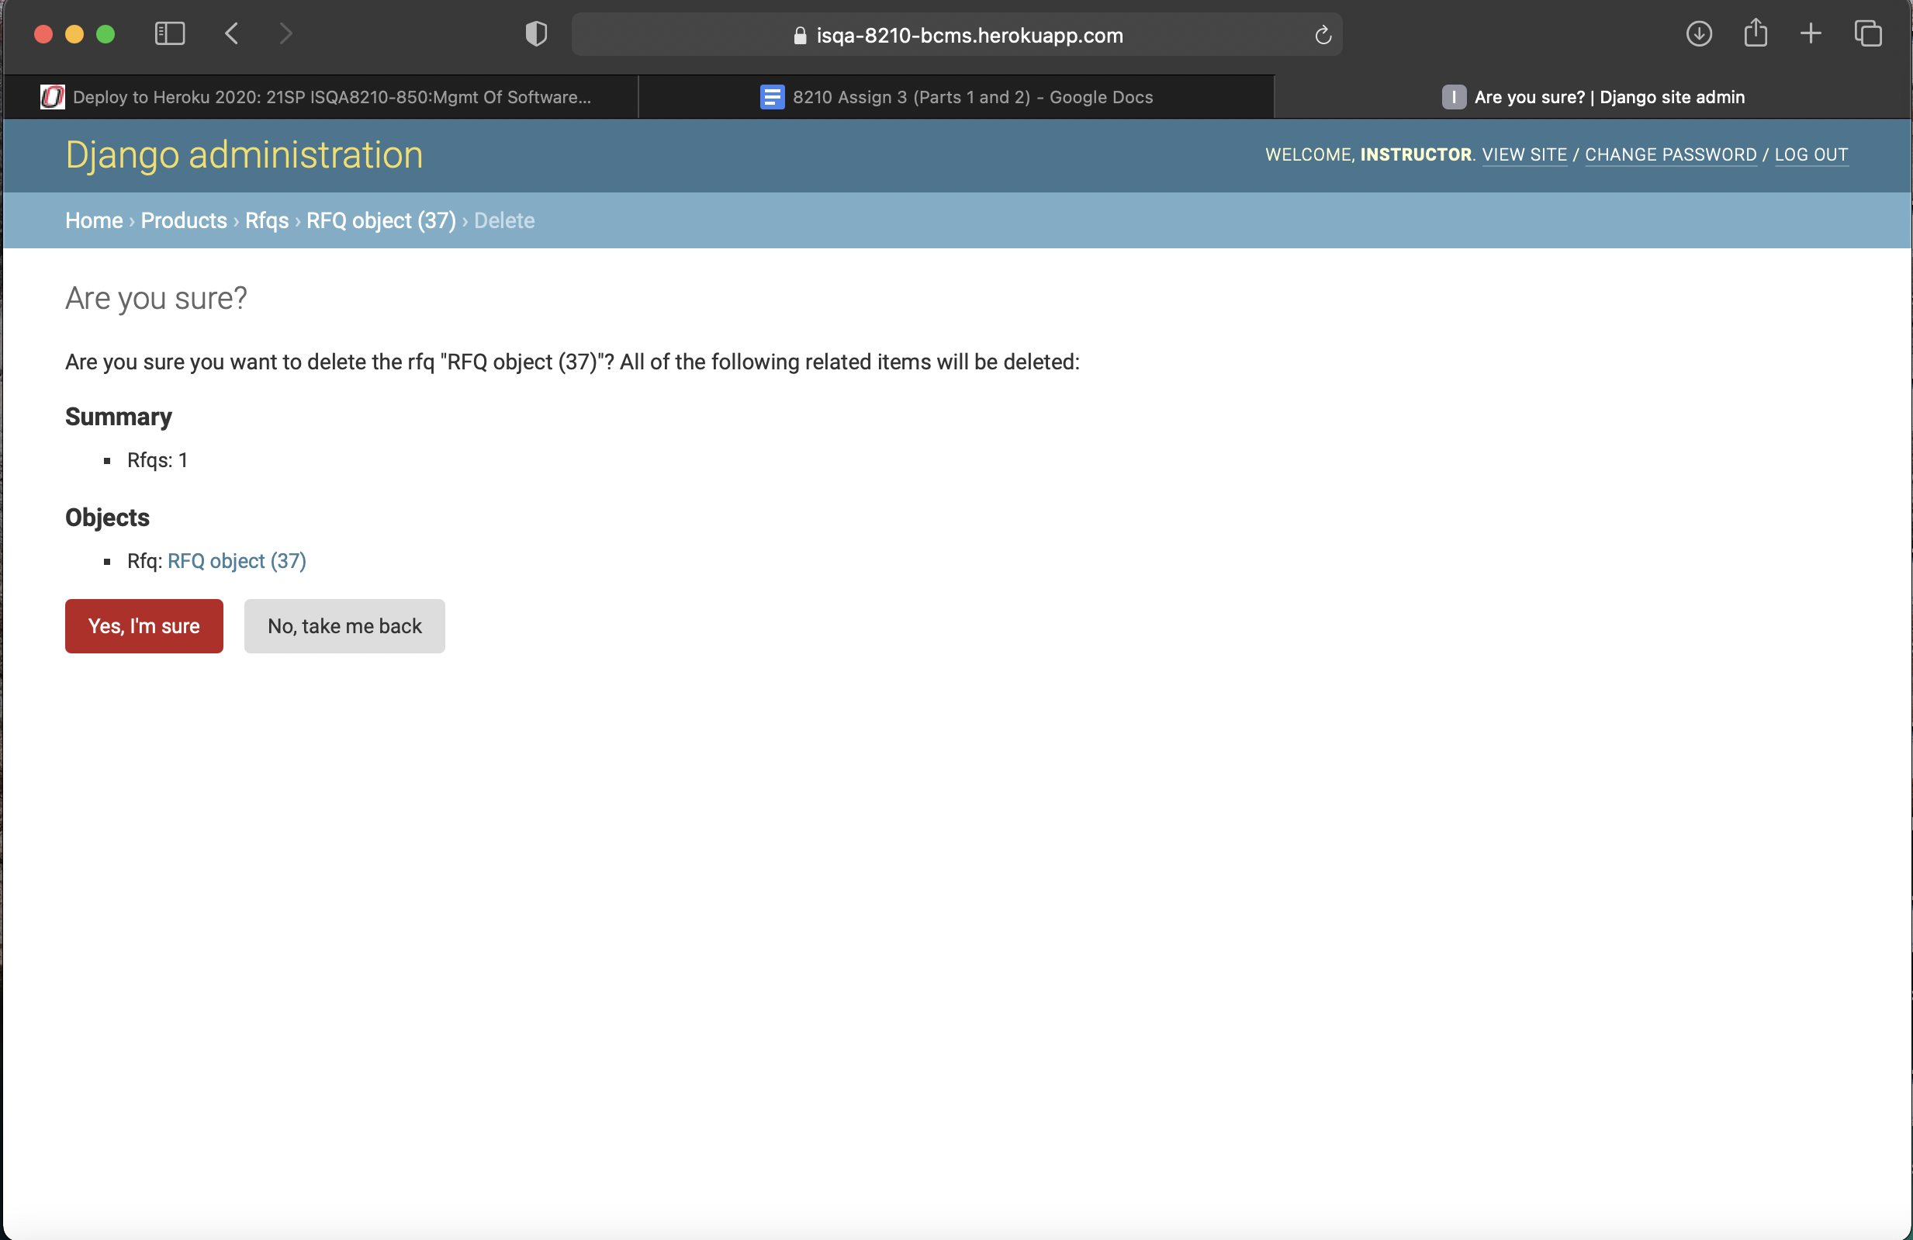

Image stored in S3 bucket Page:

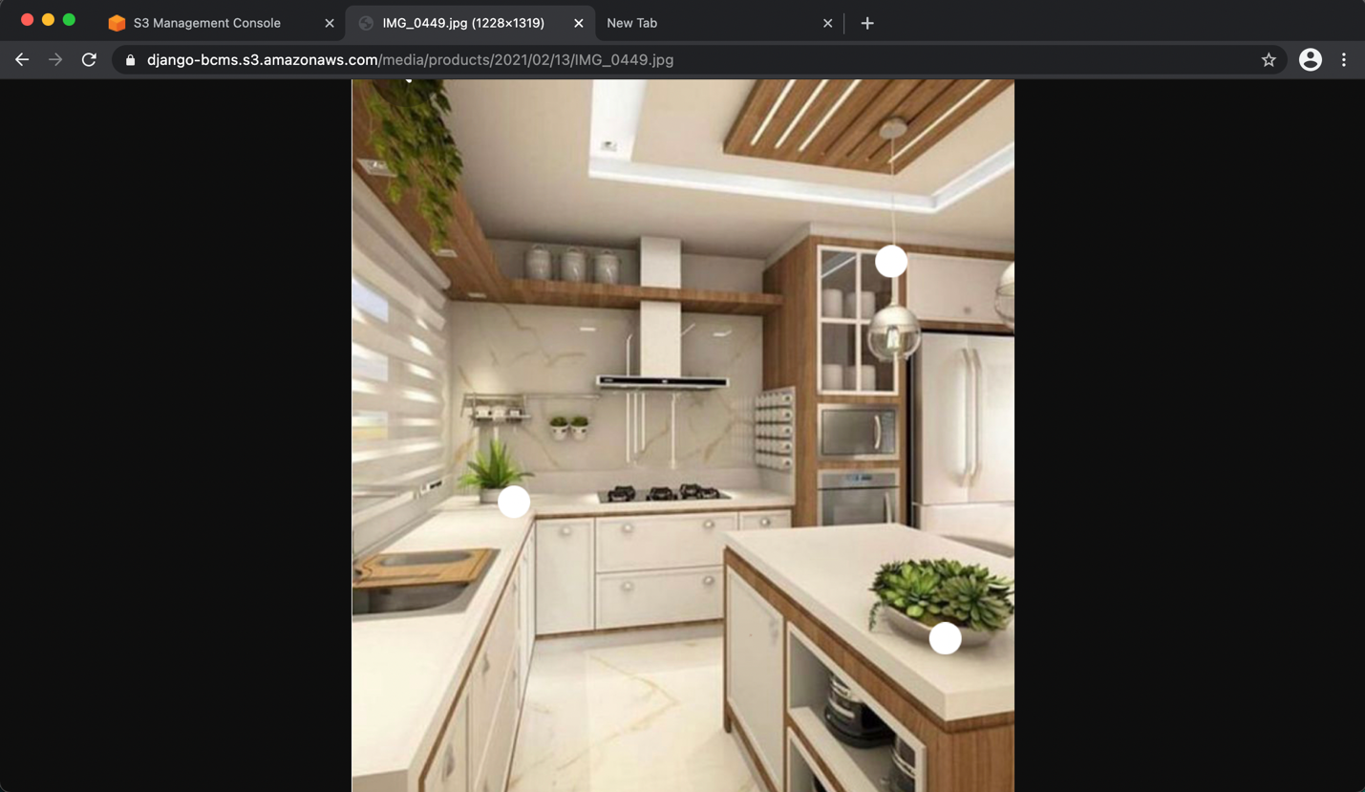

**GitHub Repository Link:**

<https://github.com/sakthipriya-07/ISQA_8210_BCMS>

(I created a private repository but I added you as collaborator)

**Heroku Link:**

<https://isqa-8210-bcms.herokuapp.com/admin/>